- Fire Life Safety

Move 911 Emergency from bottom to top

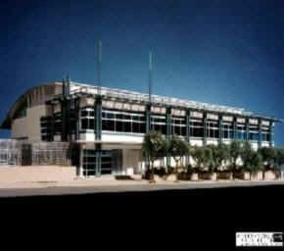

911 Emergency Center - San Francisco, California
This project was directed through the San Francisco Department of Public Works. This building was three stories including basement, first, and second floors which replaced the existing police dispatch center in the Hall of Justice. NBA provided inspection and reviewed mechanical plans and specs for constructability and budget purpose, recommended procurement of long lead equipment, provided HVAC, plumbing and fire protection engineering inspection and close out.

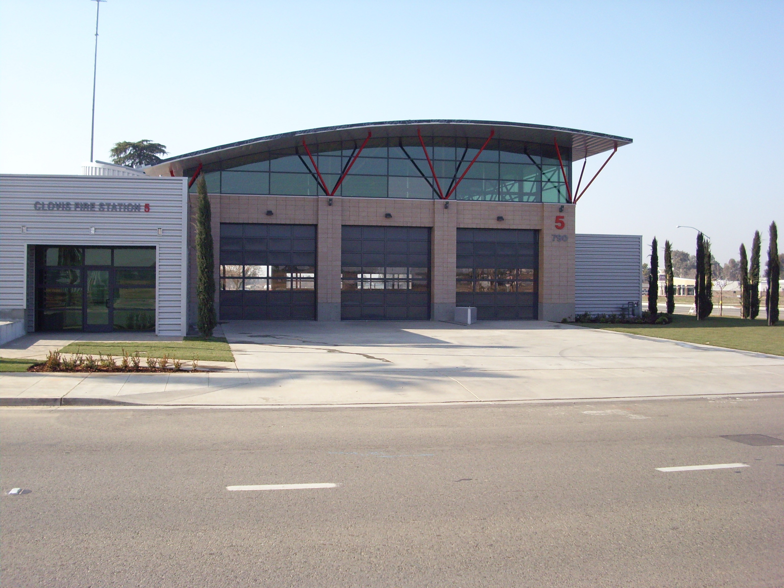

Clovis Fire Station #1 - Clovis, California
This fire substation is a one story 8,923 sq. ft. building with three fire apparatus bays for three or more engines. The building contains living quarters, a commercial kitchen with gas stove, a laundry room with a gas dryer and electric washers. NBA provided electrical design including power and lighting design for the entire fire station including HVAC equipment, electrical outlets, a phone and computer jacks. NBA provided building electrical power to Rescue Response equipment, power for shop equipment and exhaust equipment in the apparatus floor. NBA also provided emergency generator for the facility and lighting Title 24 calculations.
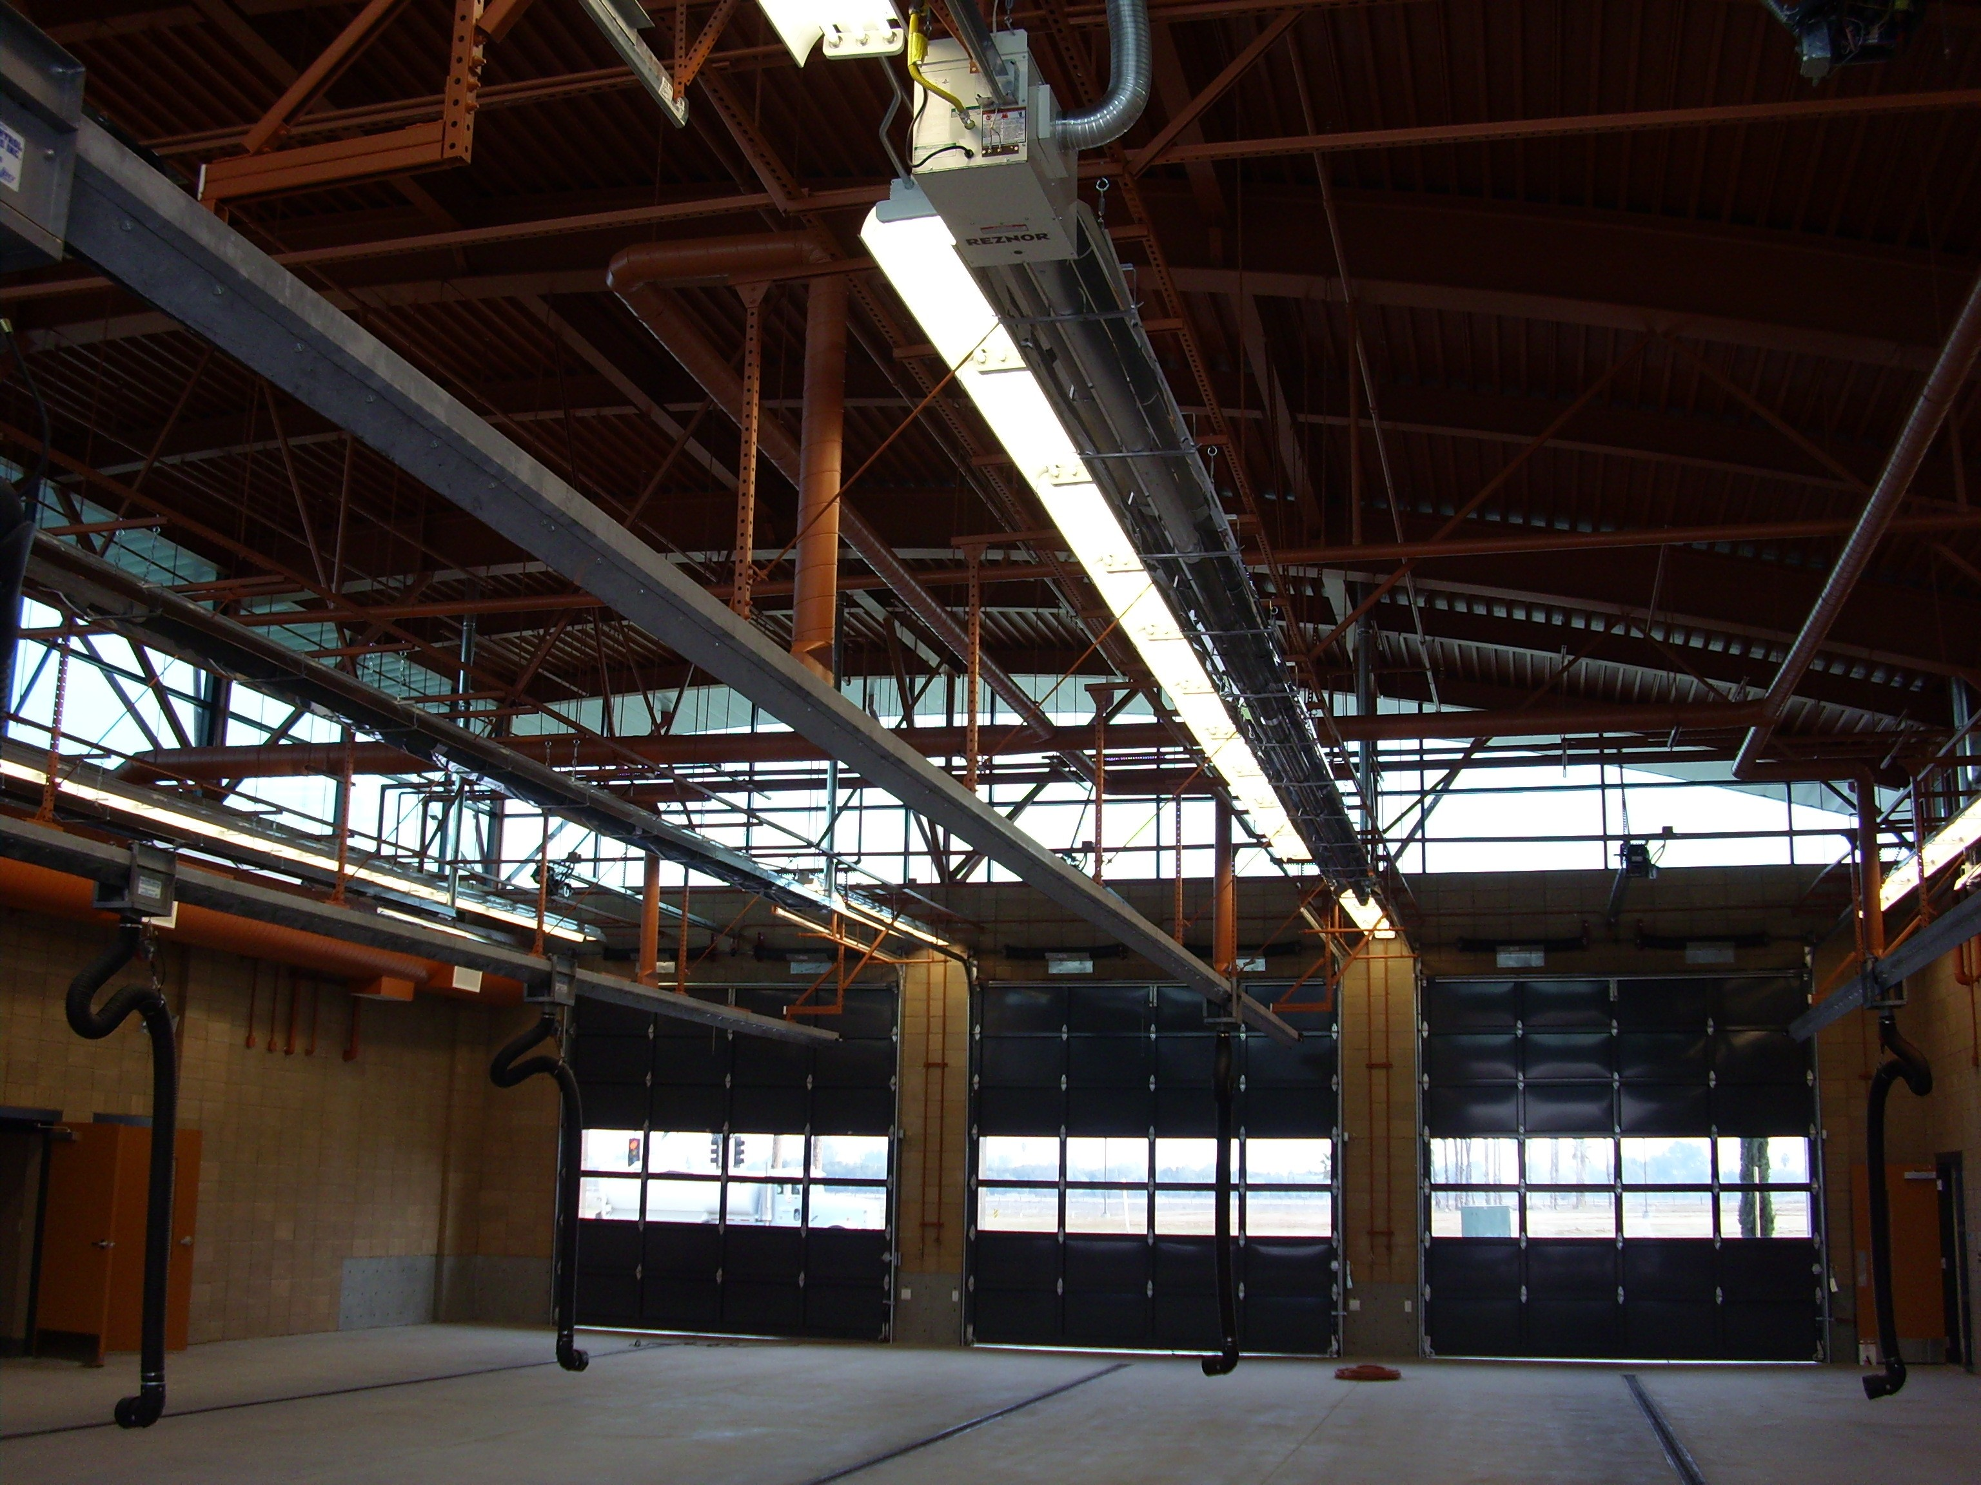

Clovis Fire Station #5 - Clovis California
The fire substation is 10,267 sq. ft. and one story. It has a commercial kitchen, and with gas fired laundry dryers and electric washing machines. There are 3 bays for more than 3 engines. NBA provided cables and power to the data center, power for equipment, i.e. air compressor, power tools, and exhaust equipment in the apparatus floor. Provided lighting and power for all appliances in the kitchen except stove which is gas fired. NBA provided assistance with photovoltaic design.
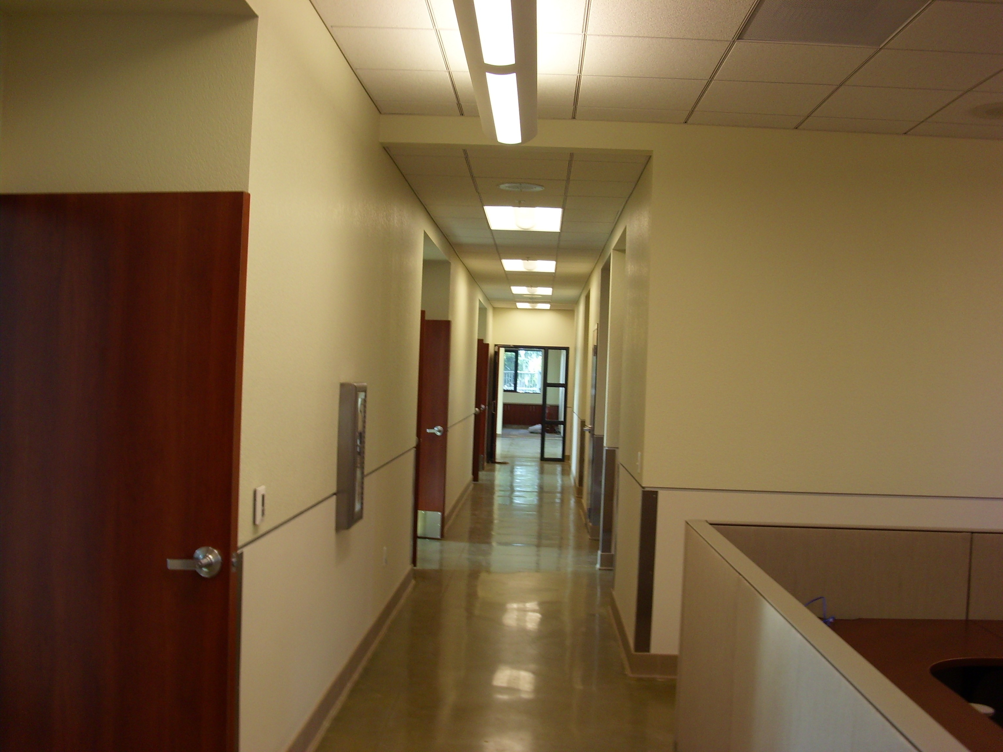

County of Merced Department of Public Works Fire Station - Merced, California
The fire substation is 4,424 (put one space here) sq. ft. and one story, with fire apparatus bays & living quarters. NBA provided power and lighting design for the entire fire station including HVAC equipment, electrical outlets, etc. including electrical power to Rescue Response equipment (battery charger, radio communication system). NBA dDesigned strong lighting in the apparatus bays, floor lights and soft lights in the dorm rooms. NBA also pProvided lighting and power for kitchen, emergency generator, and Title 24 calculations.


City of San Jose Fire Station Number 12 - San Jose, California
This is a 2 story approximately 6,000 (put one space here) sq. ft. fire station with 2 apparatus bays. NBA provided power and lighting design for entire fire station including HVAC equipment, electrical outlets, and shop equipment. NBA p Provided power, lighting and multiple phone and data lines in the training area. Provided building electrical power to Rescue Response equipment were required including battery charger, radio communication system, etc.
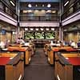

City of Oakland Emergency Center Electrical Evaluation - Oakland, CA replace CA with California
NBA provided field verifications of electrical loads through calculating existing electrical load and new electrical load due to addition of the IPSS systems. NBAWe evaluated existing emergency and UPS system load, provided recommendations for temporary use of existing wire for extra capacity, and provided detail documentation to include timeline as to placement and phasing of electrical equipment.

- Home
- Profile
- Services
- Projects
- Contact Us

- Parks & Recreation
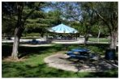

Central Park Pittsburg,- Pittsburg, California
NBA Engineering pProvided material take offs for all plumbing systems., Provided material take offs as well as for all electrical power and lighting systems. Provided construction cost estimate for both mechanical and electrical systems. NBA pProvided cold water and waste to the prefab concession unit by modifying the plumbing plans and specs. NBA also pProvided power connection to the prefab unit for lights and receptacles.
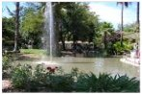

Garfield Park,- Oakland, California
NBA pProvided visual observation of the conditions of electrical relays, time clock and other equipment in the cabinet. NBA dDesigned replacement for irrigation controller. Replaced existing lighting control with new design and specified vandal proof lighting fixtures for the field as required. Responded to RFI’s. Reviewed and respond plan check comments.
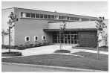

Harvey Milk Center for Recreational Arts - San Francisco, California
NBA pProvided a mechanical engineering study, an electrical engineering study, and construction cost estimates for the revival of the Harvey Milk Center. The existing 3-story, 22,275 sq. ft. center will eventually be increased to 23,000 sq. ft. The Center will house the San Francisco Photography Center and Museum, music and dance programs, and a small theatre for community self-expression.
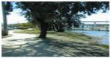

Mission Bay Parks - San Francisco, California
The parcels are 170,000 sq. ft. and the building is about 600sq. ft. NBA p Provided plans and specs specifications for park lighting, power for the Kiosk, and storage/custodian and bathroom area. NBA pProvided power for HVAC equipment and power to irrigation control systems as well as pProvided Title 24 lighting calculations.
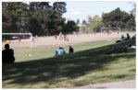

San Antonio Park - Oakland, California
Project was through the City of Oakland Parks and Recreation Department. NBA Provided a field survey to verify the existing electrical equipment and designed lighting and power systems for the new basketball court. Our firm also pProvided additional lights for the men's and women's restrooms.
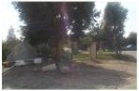

25th Street Park - Oakland, California
NBA pProvided site visit to determine the existing conditions and electrical services connection point. NBA pProvided plans and specs for park lighting and circuitry. and also pProvided two construction cost estimates; one preliminary and one final. NBA pProvided single line diagram detailing electrical connections.

I most prefer the palatino linotype font for website

If I were to have the words as below where the edges are flat and square instead of not going to end of line can you copy and paste into website so end of this line is flush?

I like Oakland army base 1st and t2 second for utilities - Under transportation projects for t2 mechanical add / Port of Oakland to it

- Utilities
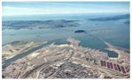

Oakland Army Base - Oakland, California
This project consisted of reviewing the gas and electrical power drawings and previous gas leakage test results for the site, providing site survey and determining the existing gas and electrical services available at the site and extra capacities that can be used for future expansion.

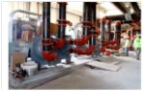
T2 Mechanical Room - Oakland International Airport / Port of Oakland - Oakland, California
The $1.4 billion airport expansion project includes a new two-level terminal complex with 12 additional aircraft gates, a central food, beverage and retail shopping area, rental car facilities, a 6,000 sq. ft. space multi-level parking garage and a two-level terminal access roadway system. NBA designed the new central plant (T2 Mechanical Room). The boilers in the mechanical room will serve the Terminal 12 with its expansion, modifications and extension. The chillers are sized to serve half of the entire future airport expansion. The emergency generators will be sized to serve T2 expansion, extension and modifications and the new parking garage with its office. The switchgears will serve the equipment in this central plant as well as T2 expansion, modification and extension. NBA was prime consultant for the new central utility plant (T2 Mechanical Room), which will serve the current Terminal Two and future expansions. NBA hired and managed the architect, structural and civil engineers, and other sub consultants and designed the Mechanical and Electrical systems using high-energy efficient equipment. Participated on green and sustainable design for this new central utility plant that accommodates the future needs of the new expanded terminal and additional facilities. This project obtained LEED Silver Rating. Oakland’s Terminal 2 recently became “the first airport passenger terminal in the United States to be awarded Leadership in Energy and Environmental Design (LEED) Silver Certification by the U.S. Green Building Council.” LEED Silver Certification of Oakland’s Terminal 2 extension and renovation was based on a number of green design and construction features that positively impact the project itself and the broader community. These features include:
- Energy efficiency measures that exceed California energy standards by 25% and reduce carbon emissions by an estimated 211 tons per year.
- Diversion from landfills of more than 80% of jobsite waste, by recycling or reusing scrap drywall, metal, plywood, carpet, and other materials.
- Water conservation measures yielding 24% less water use than in a similar conventional building.
- Selections of paint, carpet, glue, cabinetry, and plywood products that emit few or no volatile organic compounds, or VOC’s – the stuff that gives paint that strong smell- and are therefore better for the environment and our traveling public than conventional products.
- An advanced stormwater treatment system that channels runoff into plant-filled ditches, or swales, providing a natural filtering system that removes pollutants before the water reaches the San Francisco Bay.
- Innovations such as a “Green Housekeeping” program to reduce environmental and health impacts of cleaning products and chemicals used in the terminals.

Prime Consultant for the new central utility plant at Oakland Airport's new T2 two-level terminal complex. Hired and managed the architect, structural and civil engineers, and other sub consultants. Consulted on green and sustainable design for the new central utility plant, required to rminal and additional facilities.

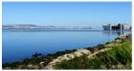

Alameda Point Buildings - Alameda, California
NBA pProvided fire supervision system study and design for Buildings 20, 21, and 22. Reviewed existing drawings and evaluated the existing sprinkler system in the three buildings. NBA also pProvided preliminary plans and specifications for the sprinkler system.
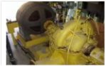

Booster Pump Station - San Francisco, California
This project consisted of demolition of all electrolyte cooling circulating pumps and installing four new city-furnished medium voltage adjustable frequency drive motor controllers. NBA iInspected installation of variable frequency drives for 900HP sewage lift pump motors, installation of one new motor and four reconditioned motors and U.P.S. system, grounding system, and installation of machine monitoring system for all four motors.

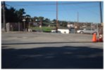

Hunters Point Dry Utilities - San Francisco, California
Approximately 1,600 residential units will mark the first construction on the 500-acre formal Naval Shipyard. NBA provided plans and specs for routing of the electrical/gas joint or single trenches to include power and gas. NBA pProvided details of these underground trenches and location of the man holes. NBA also pProvided gas electrical load calculations for the entire site and specs for electrical power supply requirement.
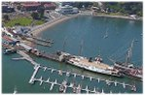

Hyde Street Harbor Water Side Facility - San Francisco, California
For pPhase one NBA we provided preliminary design and study for bilge water collection and sewage collection system, connection to existing oil water separator and pump out system. Phase two consisted of detail design and construction support of all items in phase one which consists of providing water, power and lighting to each berth, parking lot lighting, drainage system and pump station. Fire protection provided at each berth.



San Francisco PUC Joint Trench - San Francisco, California
The San Francisco Public Utilities Commission will use hydroelectric and solar power to help power the 1,600 new housing units and 300,000 square feet of commercial and retail space going up on a 93-acre site in the former Hunters Point Naval Shipyard. Estimated connected and maximum demand loads for the developments. Added load for street and traffic lighting. NBA pProvided site plan showing 12KV routing, including service point locations. NBA also pProvided spreadsheet listing major equipment including brief equipment description and quantity and cost estimates.
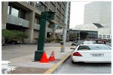

San Francisco Red Light Photo Enforcement - San Francisco, California
NBA Engineering Our firm completed the design of electrical drawings for the installation of a photo enforcement camera and completed field construction inspections of 21 intersections to verify as-built conditions. We then determined the most cost effective method for connecting the cameras and loop detectors.
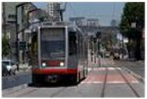

SFPUC Construction Management - San Francisco, California
As part of an On Call Contract with the San Francisco Public Utility Commission, NBA received a variety of technical service orders, including a feasibility study of adding new substations for MUNI on Third Street versus purchasing power from a PG&E remote location and paying a “wheeling” fee. Other work included reviewing drawings and specifications, site surveying, feasibility studies and other engineering services.

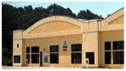

Treasure Island Natural Gas System Analysis - San Francisco, California
NBA Engineering rReviewed existing files (drawings and specifications), surveyed site, and provided complete load analysis to determine the existing gas distribution capacity. Also provided preliminary drawings and cost estimate for new gas service to buildings without gas service.

- Hotel / Resorts
St. Regis 1st
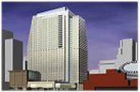

St. Regis Museum Tower - San Francisco, California
43-story hotel, condominium and cultural center development. The new 484 foot tall structure will have 19 floors of condominiums, 16 floors of five-star hotel, five floors of hotel public space, and four floors of underground parking. NBA designed the HVAC, plumbing, and reviewed electrical power, lighting, emergency power, and fire alarm system and telephone and communications system.

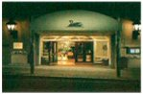

Campton Place Hotel - San Francisco, California
NBA dDesigned electrical power, lighting and 300 KVA emergency generator systems for 12-story high-rise hotel. Generator design included coordination of load to go on generator, sizing of generator and emergency transfer switch. Generator design also included design of control diagrams and routing of exhaust to the outside of the building. Witness testing and certification of emergency equipment was provided.
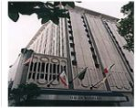

Donatello Hotel - San Francisco, California
15-story building with 2 levels of subterranean parking. Investigated the integrity of the HVAC, plumbing, fire protection, electrical power, lighting, and security systems. NBA studied the design drawings which were not representative of as-built systems (no as-built were available), maintenance reports, testing contractor reports, and fire marshal inspection report and provided an investigative report of our findings with several alternatives and cost estimates for repairs, upgrades, and / or replacement of unacceptable systems.
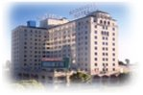

Roosevelt Hotel - Hollywood, California
A For this 12-story building., pProvided new HVAC, plumbing, fFire pProtection, eElectrical power and lighting design for this hotel with an outdoor café and restaurant. Named in honor of President Theodore Roosevelt, the Hollywood Roosevelt had its grand opening on May 15, 1927. It was built at a cost of $2.5 million. The Hollywood Roosevelt is listed on the National Registry of Historic Places.
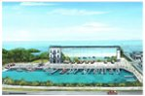

Snake Creek - Florida Keys, Florida
This project included Includes wet-slip spaces and dry-stack storage units, ships store, barbecue area, office space, a state of the art fish-cleaning station, plus other amenities. NBA provided electrical load calculations for 20 power stations/pedestal, site lighting, pump out station and fuel station and other design and engineering services.
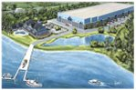

Watermark Marina - of Wilmington, North Carolina
Located near three waterways – the Cape Fear River, the Intracoastal Waterway and the Atlantic Ocean. Marina features floating dock, full-service amenities, new clubhouse with lounge, a barbecue and picnic area, and dry-stack boat storage. NBA provided complete MEP design services to the boat area and the club house building. NBA pProvided electrical, lighting and fire alarm systems for the boat storage area and club house building.

Restaurants

Blowfish Sushi to Die For - Santana Row - San Jose, California
This is a 3,000 SF sq. ft. sushi restaurant with additional 1,000 SF sq. ft. of kitchen on a first floor of a 2-story building. NBA pProvided electrical plans for power, telephone, and lighting circuiting. as well as Provided Title 24 lighting calculations and HVAC equipment forms for the plan check requirements.

GAP Tenant Improvements - Various Locations
Adhering closely to corporate standards for design quality, NBA staff provided electrical power and lighting design for 700 GAP stores nationwide, meeting demanding schedules based on store openings dates.

Saturn Dealership - Newark, California
Mechanical design included carbon monoxide exhaust, air conditioning of office areas and ventilation of maintenance areas. Electrical design included all communication and power wiring, fire alarm, lighting, and connections for all maintenance equipment and GM satellite communications systems.

Sears Sunrise Store - Citrus Heights, California
This was a 210, 00 square. Foot. conversion of basement from storage to retail space and renovation of the entire first floor. NBA uUpgraded mechanical and electrical systems including new lighting, ductwork and air diffusers for the converted area. Three fire rated corridors were added to comply with fire codes, new branch circuit panel boards were required in the basement, and new sprinkler heads and fire dampers were added.

Straits Café, Santana Row - San Jose, California
This is a 6,000 SF sq. ft. 1-story restaurant on the first floor of a five story building on Santana Row. Provided electrical plans for power, telephone, and lighting circuiting. Provided fire alarm device location on the plan and tied them into the existing building fire alarm panel. Provided Title 24 lighting calculation and HVAC equipment forms for the plan check requirements.

Williams-Sonoma San Francisco and Nationwide
Fast-Track Tenant ImprovementsAdhering closely to corporate standards for design quality, NBA staff provided electrical power and lighting design for 100 stores nationwide, meeting demanding schedules based on store openings dates.

MCA Barham, 3-story office building, 55,000 sq. ft.,- Universal City, CA
Colorado Place, Office Building, 60,000 sq. ft.,- Santa Monica, CA
Texaco Tenant Development,- Universal City, CA
10 Universal Plaza Tenant Development,- Universal City, CA
MCA lake side Plaza,- Universal City, CA
Ford Aerospace,- San Jose, CA
Syntex Corporation Building (250,000 sq. ft.),- Mountain View, CA
Arco Towers - 2 buildings 52 stories each,- Los Angeles, CA
Kaiser Redwood City - Fire Protection Rehab,- Redwood City, CA
Doctor's Office Building,- San Francisco, California A
211 Pine Street - San Francisco, CA
St Regis Museum Tower,- 37 Story High Rise,- San Francisco, CA
The Regent Hotel,- 20 Story hotel on top of 9 Story Bloomingdale store,- San Francisco, CA
The Donatello Hotel,- San Francisco, CA
May Flower Hotel,- Los Angeles, CA
Miramar Hotel,- Santa Monica, CA
Roosevelt Hotel Cafeteria,- Hollywood, CA
LA Café Discotheque,- Los Angeles, CA
Victoria Station Restaurant - Pizzeria Uno,- San Francisco, CA
Kentucky Fried Chicken - San Francisco, CA
3 Embarcadero Center, San Francisco, CA
Campton Hotel,- San Francisco, CA
Miller's Outpost - Tenant improvement in different areas of the country.
Charlotte Russe Co. - Tenant improvement in different areas of the country.
Anchor Blue - Tenant improvement in different areas of the country.
MGM Grand - Las Vegas, Nevada- tenant improvement.
Sears Sunrise Store, Citrus Heights, CA
Strip Centers,- Sacramento, California A
Lucky Supermarket,- Sacramento, CA
Chevrolet/Geo Folsom Auto Mall Dealership - Folsom, CA
Saturn Dealership Design Built Project - Newark, CA
Martin Buick and Pontiac Dealership,- Richmond, CA

Correctional Page

Alameda Juvenile Detention Center - San Leandro California
NBA Engineering was on the MVE - Rosser team that prepared the AIA award winning bridging documents. NBA completed the design criteria for HVAC, plumbing, fire protection, electrical power and lighting systems. The 450-bed juvenile facility will also have juvenile court building consisting of five courtrooms and 24,000 feet of space for administrative and other ancillary functions.

Elmwood Correctional Facility - Milpitas, California
This is one of two facilities operated by the Santa Clara County Department of Corrections. It includes the Men's Correctional Facility and the Correctional Center for Women (CCW). The Elmwood complex houses minimum and medium security inmates.
Santa Clara Detention Facility - Morgan Hill, California
Our firm provided the HVAC, plumbing, fire protection and electrical engineering services design for this new, one-story, pre-engineered auto-shop building which was part of the youth vocational educational program facility. Our firm also provided an oil/water separator, gas piping, hot/cold water, waste, and vent systems.
San Francisco Juvenile Hall - San Bruno, California
NBA with DTA (Joint Venture partner Don Todd & Associates) is providing construction management and office engineering services for this 98,000 sq. ft. detention facility containing 105 sleeping rooms, with a capacity of up to 150 beds. This will be a highly programmed, full service detention facility with associated educational, program, recreational, health care, and religious and other support.
San Quentin Village - San Rafael, California
San Quentin Village San Rafael, California For the County of Marin DPW, NBA provided the electrical design for an emergency generator. Our firm conducted electrical load calculations of existing loads, prepared a budget cost estimate and provided construction administration.
Wasco State Prison - Kern County, California
NBA provided construction documents (drawings and specifications) for HVAC, plumbing and fire protection systems. Wasco State Prison is a 620-bed medium custody facility sitting on 634 acres. Wasco was constructed in 1991 and five additional reception center dormitories were completed in 1997. Wasco has an annual operating budget of $88 million dollars and a staff of 1300.

Academic Middle School San Francisco, California
This is a two-story, 68,000 square. foot. building with a separate building as Multi-Purpose Area. Designed new energy management system for the entire school and has control at approximately 100 points. Two steam boilers and the heating/ventilation unit serving multi-purpose area had to be replaced with new ones to be controlled via Energy Management System.

Alice Fong Yu Alternative Middle School - San Francisco, California
Alice Fong Yu is the first public Chinese language immersion school in the country. Winner of Award of Excellence in the New Built Category of the 2002 C.A.S.H. /AIACC Leroy F. Green Design Awards Program. NBA provided mechanical and electrical engineering services to meet fire, safety, and ADA requirements.

Bret Harte Elementary School - San Francisco, California
Bret Harte was constructed in 1954 and had major renovation in 1969. It is 79,000 square feet and is in the Bayview Hunters Point District. Prop 39 bond money is financing major mechanical, electrical and plumbing and fire protection upgrades. It is being designed under CHPS guidelines.

Buena Vista Elementary School San Francisco, California
This is a two story 32,500 square. Foot. building. NBA pProvided construction documents for new lighting fixtures in corridors, classrooms, multipurpose room, staff lunch room, offices, rest rooms, computer networking, and security system. NBA rReplaced circulating pump and outside air thermostat. Provided new energy management control panel, remodeled two toilet rooms, and replaced toilet exhaust fans and existing water fountains

Cobb Elementary School - San Francisco, California
Part of Phase II of San Francisco Unified School District School Building Improvements. NBA rReplaced plumbing fixtures on second floor boys' and girls' toilet rooms to comply with ADA requirements and changed flushing arrangements for urinals from automatic (using timer) to manual.

Daniel Webster Elementary School - San Francisco, California
This is a 42,800 SF sq. ft. building that was built in 1936. NBA dDesigned emergency lighting and exit signage. Surveyed building, provided cost estimates (unit prices) for florescent lamps, ballast’s and lenses. NBA pProvided HID fixtures in auditorium. Added additional receptacles in teachers room and exhaust fans for the computer rooms.

Douglas High School - San Francisco, California
This is a two story 22,000 square foot building. Project was OLA funded project consisted of renovation and code upgrade of heating, plumbing, and life safety systems. Also improvements were made to meet ADA requirements and other energy saving designs were was also implemented.

Edison Elementary School - San Francisco, California
This is a three-story 59,200 square. Foot. building. NBA designed new fire alarm system including horns and strobes (ADA requirements). Also, NBA provided electrical power, cabling and panels for additional outlets serving computers and printers in all classrooms. Also NBA provided infrastructure for future computer networking.

El Dorado Elementary School - San Francisco, California
NBA pProvided design and construction documents for demolition of plumbing fixtures, including water closets, urinals, lavatories, and classroom sinks. The new work includes installation of fixtures in 4 different bathrooms and classroom sinks with drinking fountain bubbles in six different classrooms.

Fremont Unified School District - Fremont, California
NBA pProvided electrical power plan for modification and addition of electrical outlets, smoke detectors, and telephone conduits. Modified the lighting layout, performed Title 24 energy calculations. Also provided construction administration, reviewed shop drawings, and responded to RFI’s.

George Washington High School - San Francisco, California
NBA pPerformed a walk-through and generated a report on the HVAC and plumbing needs of the school for Phase II of the San Francisco Unified School District School Building Improvements.

John O'Connell High School - San Francisco, California
Redesigned complete HVAC plumbing, fire protection, and electrical systems for five-story 200,000 SF sq. ft. vocational high school damaged by 1989 earthquake. The building required many specialty HVAC and plumbing systems for different vocational shops and laboratories.

Los Arboles Elementary School - San Jose, California
NBA pProvided complete mechanical/plumbing engineering services for all phases of the project, including schematic design, design development, construction documents, bid/award and construction administration. NBA pProvided Title 24 energy compliance calculations for mechanical systems and building envelopes.

Luther Burbank Middle School - San Francisco, California
NBA pProvided plumbing and ventilation repairs to classrooms and bathrooms and renovation to boys’ and girls’ bathrooms to comply with ADA requirements. Provided a report and determined the scope of work with construction cost estimate.

Malcolm X Elementary School - San Francisco, California
Part of Phase II of San Francisco Unified School District School Building Improvements. NBA dDesigned plumbing system to replace 13 plumbing fixtures in different toilet rooms to comply with ADA requirements. Provided new drinking fountains, replaced existing air compressor and ventilation system in teachers' lounge as well as three toilet rooms.

Mission Education Center - San Francisco, California
This project was among Phase II of San Francisco School District projects. Reviewed existing plans for air distribution and rebalanced the entire system. NBA pProvided construction documents for testing and balancing, control upgrade, replacement of existing air compressor and supply air fans to the building.

Mission High School - San Francisco, California
Feasibility study that lead to design for modernization, renovation and code upgrade including ADA compliance of mechanical and electrical systems for 260,000 SF sq. ft., 5-story building. Project included auditorium, classrooms, and science computer laboratories. This project was part of the Phase I San Francisco Unified School District School Building Improvements. Tasks consisted of replacing the central plant steam boiler system, vacuum pump, sump pump, and all other accessories.

Santee Elementary School - San Jose, California
Modernization work and conversion of library to a faculty room, renovation of kitchen, conversion of the media center back to a stage for the multi-purpose room. NBA uUpgraded power in all the rooms, ventilation for bathrooms and HVAC distribution modification. Also, aAdded a janitor closet, new fire alarm and emergency lighting system.

Sand Path Academy Project - San Francisco California
NBA pProvided project management, engineering and supervision of design of HVAC, plumbing, fire protection including electrical power distribution systems for an existing 8,000 SF sq. ft. of retail space converted into a school facility for mentally handicapped children. The facility design included mechanical and electrical systems for new classroom, conference, library, restroom, and meeting rooms.

San Francisco Community Elementary School - San Francisco, California
This project was part of among phase I of San Francisco School District projects, a 34,000 SF sq. ft. building that was built in 1911. The project consisted of redesigning plumbing and ventilation systems for Girls and Boys bathrooms to comply with ADA and designing fire protection system for the kitchen hood.

SFUSD "On-Call" Construction Management - San Francisco, California
This project consisted of construction management for twenty-six schools throughout San Francisco. Our tasks included: inspection, constructability review, cost estimate, punch list and close out as well as other CM work.

Oakland Unified School District - Oakland, California
NBA dDesigned the sanitary waste and domestic water services for portable classrooms at 41 school sites throughout the Oakland area. These projects included sink additions, bathroom, ADA compliance, utility connections and contacting Fire Marshall. Performed site visits and evaluated capacities of existing utilities.

Roosevelt Middle School - San Francisco, California
This project was among phase I of San Francisco School District projects; a 121, 000 SF sq. ft. building that was built in 1930. Designed new fire alarm system for the entire school, designed under the floor power for the computer room and conduits for LAN and control/patch panel and reconnecting the equipment in the relocated wood working shop.

Sunshine High School - San Francisco, California
Renovation and code upgrading of heating, ventilating, plumbing and fire life safety systems of a two-story, 47,000 SF sq. ft. building. NBA uUpgraded handicapped toilets to ADA requirements. Performed an evaluation and needs assessment.

Thurgood Marshall Academic High School - San Francisco, California
This is a college prepatory high school constructed in 1957. It is 134,000 square feet and averages about 1000 students per year 90%of whom graduate. NBA provided design for long over due renovations to electrical, HVAC, and plumbing and fire protection systems. It is being designed using California High Performance Schools guideline and is a DSA project.

Sutro Elementary School - San Francisco, California
NBA pProvided construction documents for plumbing on first and second floors. Provided new handicap accessible drinking fountains at Community Center exterior. NBA also pProvided additional electrical outlets and new walls in each classroom and computer room. New floor mounted electrical outlets were included as well as new outdoor security lighting, and repaired heating and ventilating unit control system.

Winfield Scott Elementary School - San Francisco, California
This 33,000 SF sq. ft. building was built in 1930. NBA mModified boys/girls bathrooms to comply with ADA requirements. Replaced sink, water, and gas piping for the stove in the Nutrition Area. Also, NBA pProvided new sinks in all childcare rooms and classrooms, water lines and drains for kitchen area. NBA pProvided new accessible drinking fountains.

